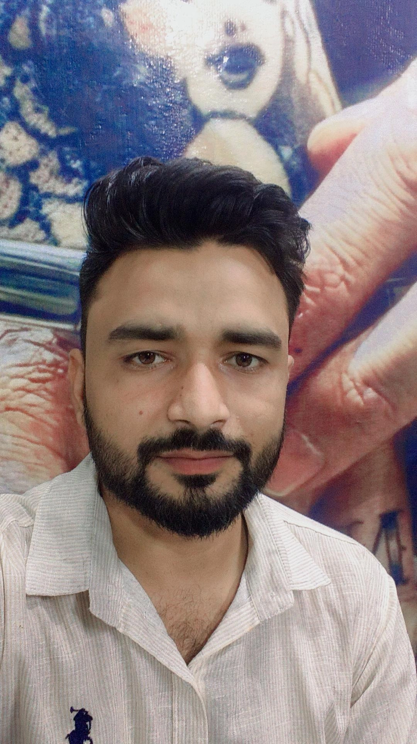ABHISHEK MISHRA s/o AVADHBIHARI MISHRA
DOB- 10/10/1995
ADDRESS - GRAM MAJHGUWAN PATOL POST KUAKHEDA BAZI DIST DAMOH Katni (m.p)
mob.-9399860978

Summary
Highly motivated and results-oriented professional with 3 years of experience in the banking sector, specializing in sales and customer service. Proven ability to achieve sales targets and build strong client relationships. Seeking to leverage my expertise to contribute to a dynamic financial institution.
Experience
- Sales Executive | ICICI Bank, Damoh Branch | (2 years)
  - Successfully achieved and exceeded sales targets for various banking products, including loans, credit cards, and insurance.
  - Developed and maintained strong relationships with clients, providing excellent customer service and resolving inquiries.
  - Identified new business opportunities and contributed to the growth of the branch's customer base.
  - Managed a portfolio of clients, ensuring their financial needs were met.
- Position Title - if known, otherwise leave blank or use "Banking Professional" | ESAF Bank | (1 year)
  - Add 2-3 bullet points here describing your responsibilities and achievements at ESAF Bank. If you don't remember the exact title or specific achievements, you can use general banking duties like "Assisted customers with banking transactions," "Processed loan applications," or "Provided information on banking products."
Skills
- Sales & Marketing
- Customer Relationship Management (CRM)
- Financial Product Knowledge (Loans, Credit Cards, Insurance)
- Client Acquisition
- Problem Solving
- Communication (Verbal & Written)
- Teamwork
- Microsoft Office Suite
Education
- 10th mp board-----2013 ------ 45.60%
- 12th mp board------ 2015 ----- 66.20%
- De.led mp board--- 2017 ---- -79.25%
- BA. mcbu ----- - 2019 ----- 72.00%
- PGDCA mcub.---- --2021 -------- 89.25%
- MSW 1st year complete Running

  - Relevant coursework or achievements, if any
Contact
- Phone Number 9399860978
- Email Address abhimishra0662@gmail.com

•personal -:

Language - Hindi& English
. Gender - Male
. Nationality – Indian
. Married status - Married

