LINKEDIN

ANKIT KUMAR
INTERNATIONAL SCHOOL OF BUSINESS & MEDIA POST GRADUATE DIPLOMA IN MANAGEMENT MARKETING & FINANCE
Email: kumarankit41233@gmail.com|| Ph.: 7667383058| Bihar ,Patna|DOB:06-09-1999
EDUCATION

PGDM (2021-23)
Graduation | 2020 | CGPA/PERCENTAGE: 6.40
Impact college, Patna HSC | 2017 | CGPA/PERCENTAGE:42.4
Jai Prakash college Ara, Bhojpur SSC | 2015| CGPA/PERCENTAGE:45.8
TP high school Bihta, Patna
ACHIEVEMENTS

SKILLS
- Leadership
- Teamwork
- Dedication
- MS word
- Goal oriented
- Team oriented
EXECUTIVE SUMMARY
To secure a challenging position in a reputable organization to expand my learnings, knowledge, and skill. To use my skills in the best possible way for achieving the company goals.

MAGNIK INDIA, Location: -Noida, Sector62
Designation |21 MAY 2022– 21 AUGUST 2022
Roles & Responsibilities
- Lead Generation Techniques
- Understanding Consumer Behavior
- Teamwork &Planning
- Corporate Ethics
- Pressure handling
Learning Outcome
- The Summer Internship Project helped me to gain Practical Knowledge of the newspaper and magazine industry, specifically on e-commerce platform, Understanding of customer behavior

Total work experience

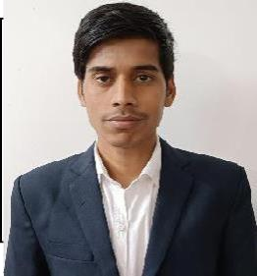
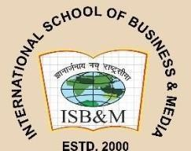


  - Company name rishabh world as a market research analyst I am working there 2 years. 2jan 2023 -4Feb 2025
  - Currently working in itc food company as a sales officer post 7 July 2025 To 28 february 2026.

    - Case Study on Marketing Strategy of McDonalds.
    - Case Study on Branding Strategy of Amul.
    - A report on Marico reach in the market.

    - Participated in village cricket tournament
    - Participated in 500 m race

