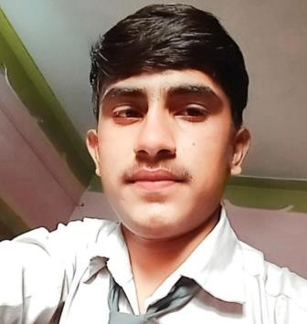
Resume

Abendra mishra
Address

Bhopal Madhya Pradesh Mobile Number 7898482194
Email Id

abendramishra@gmail.com

CAREEROBJECTIVE

To make a good position in a reputed company and work enthusiastically in team which provides steady career growth along with job satisfaction , challenges and give value contribution in the success and to build a challenging career with honesty and loyalty by translating my experience knowledge ,skills and abilities into value for an organization
ACADEMICQUALIFICATION

ExameName | Board/ University | Passingyear | Marks % | Division
10th | Madhya Pradesh board | 2018 | 68 | 1st
12th | Madhya Pradesh board | 2020 | 79.4 | 1st
PROFESSIONALQUALIFICATION

ExameName | Board/ University | Passingyear | Marks % | Division
Graduation (Bsc) | Awadhesh pratap singh university rewa | 2023 | 60 | 1st
Diploma (Pgdca) | Makhanlal Chaturvedi University | 2024 | 72 | 1st
WORKEXPERIENCE

Sales Executive – Prism Johnson Limited (Prism Cement), Bhopal, Madhya Pradesh

Job Responsibilities:
- Managed cement sales in Bhopal and nearby territories through dealers and retailers.
- Developed new dealers, retailers, and contractors to expand market coverage.
- Achieved monthly sales targets by generating regular orders and increasing product visibility.
- Visited construction sites to promote cement products and identify new business opportunities.
- Built and maintained strong relationships with dealers, distributors, and key customers.
- Conducted market surveys, monitored competitor activities, and reported market trends to management.
- Coordinated with logistics and distributors to ensure timely product delivery.
- Collected payments, followed up on outstanding dues, and resolved customer complaints.
- Prepared daily sales reports, sales forecasts, and market feedback for the Area Sales Manager.

  - Promoted company schemes and dealer incentive programs to increase sales and customer engagement.

Worked as sales and marketing in micro finance telecalling.

PERSONALDETAILS
Date of Birth 16-09-2003
FatherName Dharmendra mishra
Mother Name Saraswati mishra
Nationality India
Marital Status unmarried
Language Hindi, English (basic)
Hobbies Cricket, movie's, Songs

Gender
Zip Code
male

484665
Declartion
Thereby declare that all the statement made in this resume are true, complete and correct to the Knowledge.

Date:
Place:
Abendramishra

