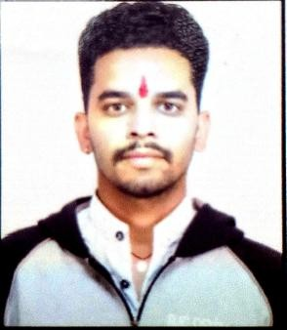
RESUME

SHIVAM KUMAR SHARMA
Address: Sagar, M.P.
Phone: +91 8349332007 | Email: sharmashivam9826@gmail.com

CAREER OBJECTIVE
To secure a challenging position in a professionally managed organization where I can utilize my conceptual and functional skills to contribute to the company's growth while enhancing my personal career development.

WORK EXPERIENCE
Team Leader – HDFC Bank
Roles & Responsibilities:
- Led and managed a team of Sales Executives to achieve monthly sales and business targets.
- Guided the team in promoting banking products such as Savings Accounts, Current Accounts, Personal Loans, Credit Cards, and Insurance.
- Monitored daily team performance, prepared MIS reports, and shared updates with the Branch Manager.
- Conducted team meetings, training sessions, and field visits to improve productivity.
- Built and maintained strong relationships with customers while ensuring excellent service.
- Ensured accurate documentation and compliance with HDFC Bank policies and KYC guidelines.
- Resolved customer and team issues promptly to maintain smooth branch operations.
- Identified new business opportunities and supported the team in achieving revenue growth.

HDFC BANK | KCC Collection Executive
- Managed Kisan Credit Card (KCC) collection processes and customer follow-ups.
- Handled financial documentation and maintained recovery records.
- Ensured timely communication with clients regarding payment schedules.

ACADEMIC QUALIFICATION

Examination | Board / University | Year | Marks | Division
B.Com | Barkatullah University, Bhopal | 2019 | 1519 | 2nd
12th (HSC) | MP Board, Bhopal | 2015 | 280 | 2nd
10th (SSC) | MP Board, Bhopal | 2013 | 273 | 2nd

PROFESSIONAL QUALIFICATION
- DCA (Diploma in Computer Applications)
MCU Bhopal | 2016 | 1st Division (435 Marks)

SKILLS & LANGUAGES
- Technical Skills: MS Office (Word, Excel), Data Entry, Basic Computer Operations.
- Languages: Hindi & English (Professional Proficiency).
- Core Strengths: Communication, Problem-solving, Collection Management.

PERSONAL DETAILS
- Father’s Name: Mr. Netram Sharma
- Date of Birth: 25-03-1996
- Marital Status: Unmarried
- Hobbies: Playing Volleyball, Reading.

DECLARATION
I hereby declare that all the information provided above is true and correct to the best of my knowledge and belief.

Date:

Place: Khurai

(SHIVAM KUMAR SHARMA)

