CURRICULUMVITAL

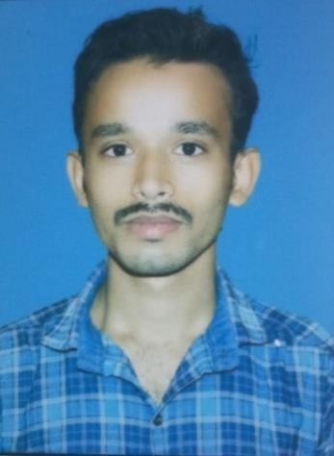
SidhantaKumarBehera
ContactNo:9938894600
EmailId:sidhantkumarbehera7@gmail.comAt: Paripalei
Post:Kusunpur Dist: Bhuwaneswar State: Odisha PIN: 754207

OBJECTIVE:-
To Have a challenging position in an organization for utilizing my knowledge. Talent and abilities for the growth of that organizationandalsotoacquireknowledge,experienceandtosatisfy my goals through my chosen organization and work field.

AREAOFINTREST:-
- Garmentmanufacturing

HOBBIES:-

- PlayingCricket
- ListeningMusic
- Learningaboutnewgadgets

EXPERIENCE:-
Company Name: Shree Ganesh Electricals
Designation: Sales Executive
Items:** Electrical wires, switches, LED lights, fans, MCBs aur other electrical accessories.

Experience:Handled dealer visits, generated new customers, managed order bookings, and achieved monthly sales targets in Bhubaneswar and nearby areas.
LuxCoziQualityControl(1.5)years

ACADEMICQUALIFICATION:-

SL.NO. | EXAM.PASSED | BOARD/UNIVERCITY | YEAROFPASSING | PERCENTAGE
1 | 10th | HSC,ODISHA | 2014 | 60.16%
2 | DiplomaTextileTech. | SCTEVT,ODISHA | 2020 | 56.84%

STRENGTH:-
- Punctual
- Sincere

PERSONALPROFILE:-
Name:-SidhantaKumarBeheraC/O: -Radhakanta BeheraDOB: -17/10/1998
Gender:-Male

MaritalStatus:-UnmarriedNationality: -IndianReligion: -Hindu
Language:-Odia,Hindi,English

DECLARATION:-
Isolemnlydeclarethattheentireparticular furnishedaboveare true to the best my knowledge and belief. I lookforward to a chance to prove my competence.
Date: -Signature
Place:-Paripalei SidhantaKumarBehera

