Harsh Choubey
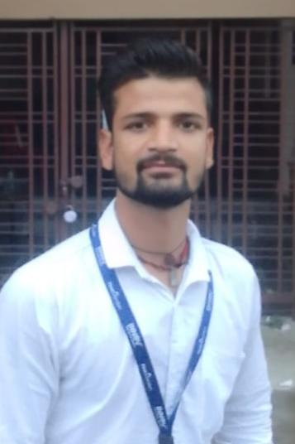
Address gopalgunj tili road sagar mp

Email- hchoubey347@gmail.com
Contact no- 9174025191

Objective:

To learn and develop skills in the application of theory to practical work situations and to draw inferences from it which can be useful in future work and college evaluation, also to learn and industrial working procedure.

Educational Qualification:

Qualification | Name of Institute | University/Board | Year of Passing | %Secured/  CGPA
10th | Saraswati shishu mandir | M.P. Board | 2018-19 | 71.3%
12th | GOV High School | M.P. Board | 2020-21 | 73.4%
BA | Arts and Commerce College | State University | 2024 | B
MA | Rani Avantibai University | State University | 2025 | Rining

Working Experience

Job Profile :- Managemant & Sales (1 Years 6 Month of Experience)

;- as a team leader . dynamic & ultratech [ 1 year 3 month of Experience ]

Company Name :- Ultratech Cement .

° Roles and Responsibility as a field officer.

° Experience of on line . Dealer & Distraibutor good Cummucatiom & Sales
Activities/Interests:
- Social Work, Travelling,
Personal Profile

- Gender: Male.
- Date of Birth: 26/03/2003.
- Nationality: Indian.
- Marital Status: Unmarried.
- Languages Known: English, Hindi.
- Personal Strength: Leadership skills, Self-confidence, Optimism and Hard working.

Declaration:
The information provided in this document is true to the best of my knowledge. Therefore I hereby take the responsibility of the authenticity of the information provided.

